**Time Tracker App**

Takes user to the report section

Takes user to the main time entry form



The link to the report section is disabled on page load. It gets enabled when the user creates an entry. If all the user entries are deleted, the link to the report section gets disabled again.

**Weather section**

On page load, the weather section is not populated when app loads.



Default unit is Celcius

User can click to display weather. Only 50 clicks/day as per API documentation

After the user clicks on the button to get the latest weather conditions the following things are displayed:

Latest weather condition icon, current temperature, minimum temperature, maximum temperature, humidity, wind speed and wind direction, respectively.

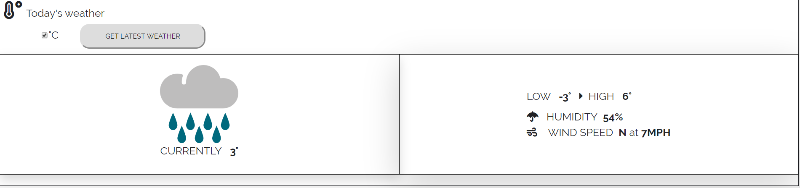

Temperature displayed in Fahrenheit:

In order to display the weather in Fahrenheit, the user needs to uncheck the box next to the temperature unit(C).

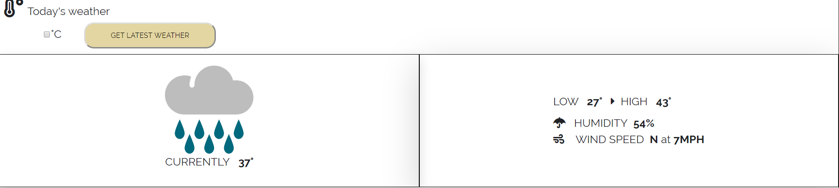

**Time Entry Form:**

To create a successful entry, the following fields are required:

Title, date, category, duration (hours & minutes).

Auto-populated (mm/dd/yyyy)

Word limit for user is 25 characters

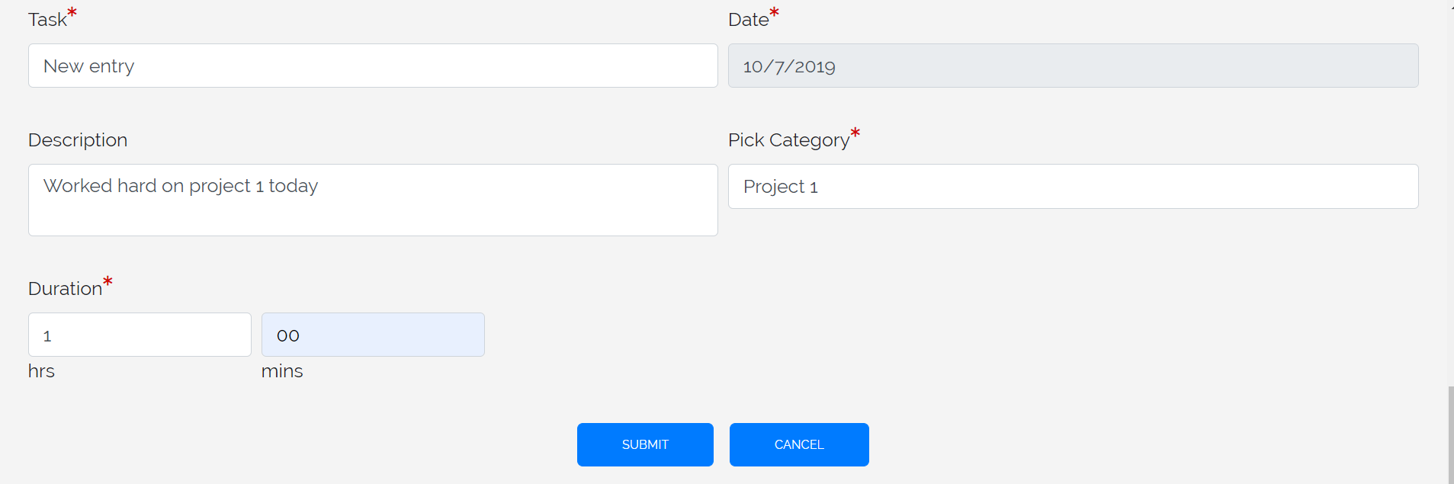

Resets the form

Creates a new user entry

After the new user entries are created, they are displayed in a grid for the user.

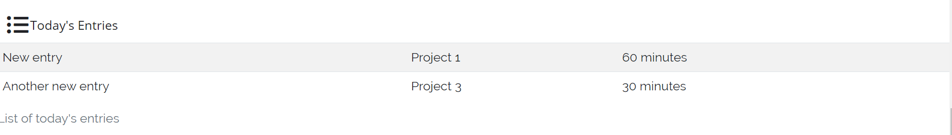

The user can also edit(todo) and delete entries

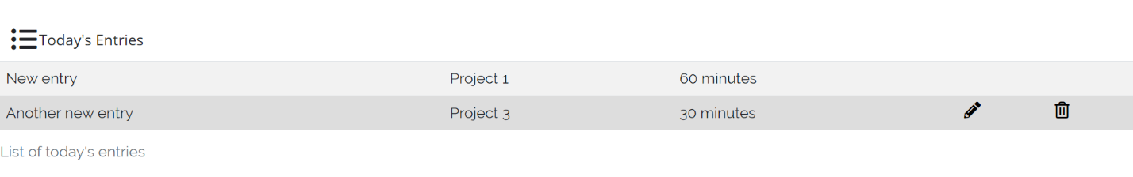

The time is converted to minutes

Delete current entry

The user can make multiple entries for a category and all of them are displayed.

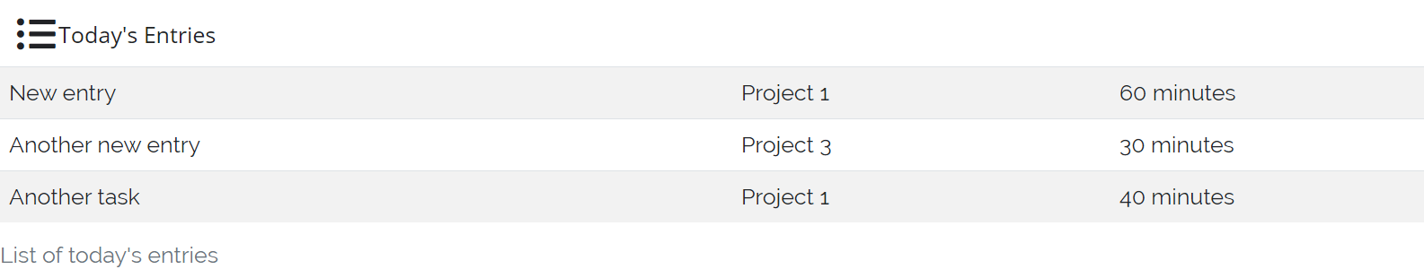

**Report Section**

Once an entry is created, a pie chart is generated. If the user created multiple entries for the same category, all of them are grouped up and total time duration is displayed to the user.

The report section is not available until the first entry is created by the user. If the user deletes all the entries, the report section is not displayed anymore.

If the user deleted an entry for a category that has multiple entries, the change will be reflected in the pie chart as well.

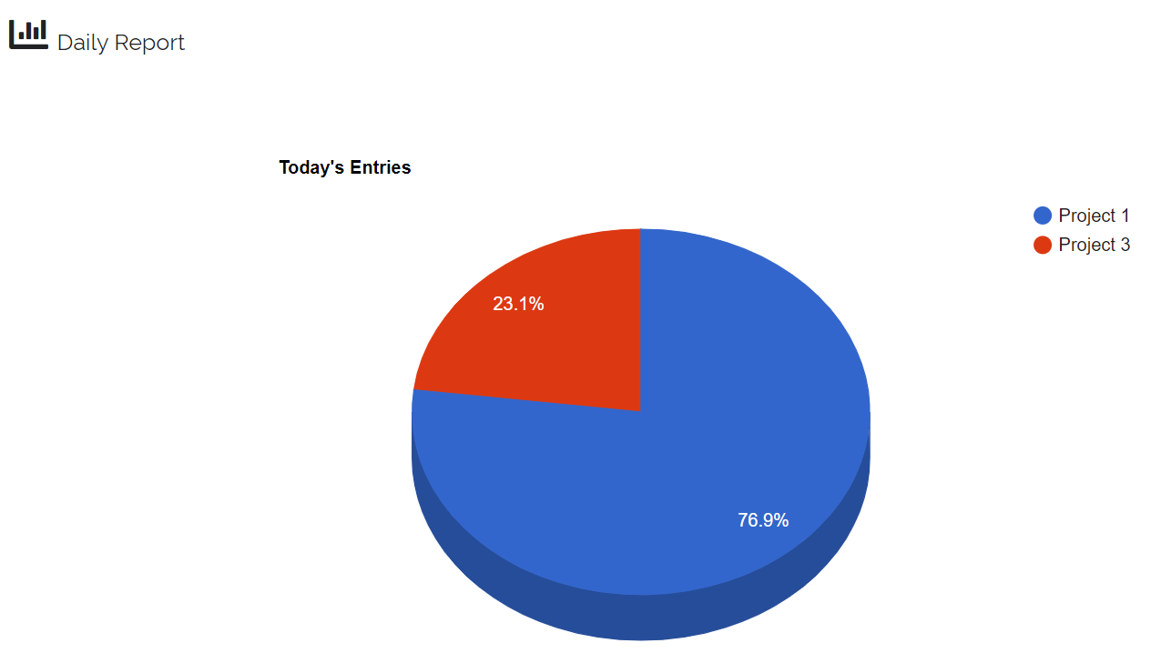

**Footnotes:**

Weather API- <https://www.metaweather.com/api/>

Charts: <https://developers.google.com/chart/interactive/docs/gallery/piechart>